**Lab 3 report**

Ziv Zaidman 208660365

Guy Leiba

**Hamming47 code screenshots**:

1. 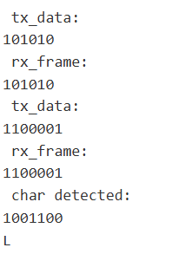



1. 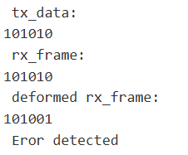



1. A screenshot of a computer code

   Description automatically generated



כפי שניתן לראות קוד Hamming לא זיהה טעויות.

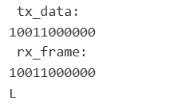**CRC code screenshots**:

1. A computer code with numbers and symbols

   Description automatically generated